Contents

1.URL to download SP: 1

1.1. Definition for User 1

2.SharePoint Admin center 2

2.1. Site collection 2

2.2. Creating New site collection 2

2.3. Adding Users 2

**Part 1: About Environment setting**

**VedioLink:** <https://www.youtube.com/watch?v=N-vDSxmQ4CY&list=PLTnyE_-cZNW1o-ZbFohq-D7K8ddNOS0tu>

In this chapter, we will be using the Office 365, which is cloud-based version.

**Step 1.** You can easily create a free trial account here <https://products.office.com/en/business/office-365-enterprise-e3-business-software> => [**Free trial**](https://go.microsoft.com/fwlink/p/?LinkID=403802) => sign up on

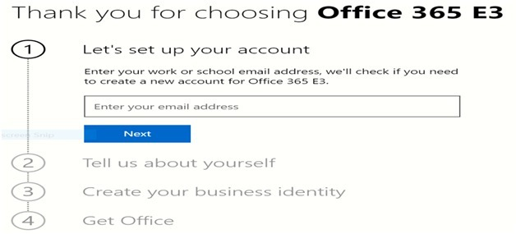

**Or inshort**

# 1.URL to download SP:

[**https://businessstore.microsoft.com/en-us/create-account/signup?offerid=B07A1127-DE83-4a6d-9F85-2C104BDAE8B4&dl=ENTERPRISEPACK&ispolaris=1&culture=en-US&country=US&ali=1&products=cfq7ttc0k59j:0009**](https://businessstore.microsoft.com/en-us/create-account/signup?offerid=B07A1127-DE83-4a6d-9F85-2C104BDAE8B4&dl=ENTERPRISEPACK&ispolaris=1&culture=en-US&country=US&ali=1&products=cfq7ttc0k59j:0009)

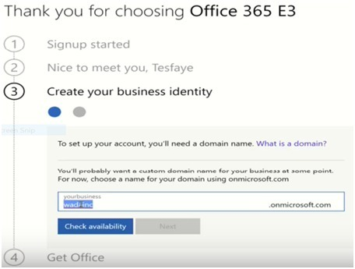don’t forget this company name.

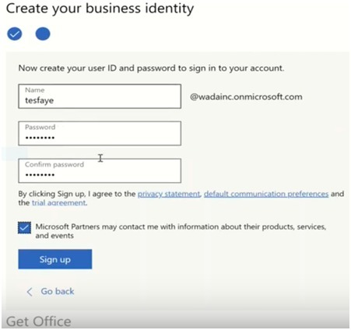

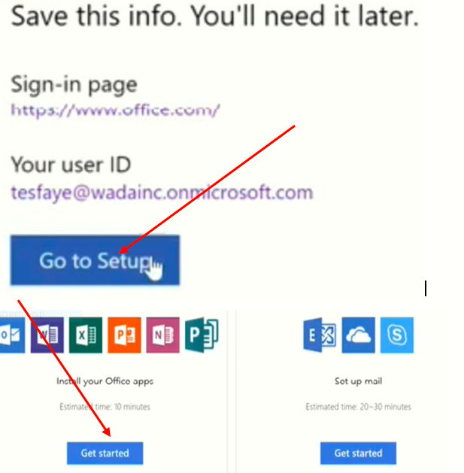

**Exit and continue later**

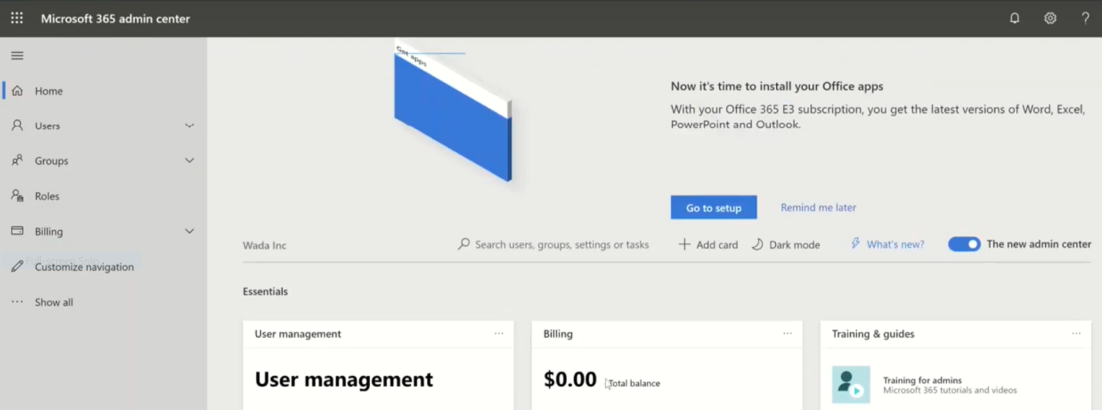

Go to New tab and Open **Office.com** then sas(software access service) is **opened =>Admin then we get the following page**

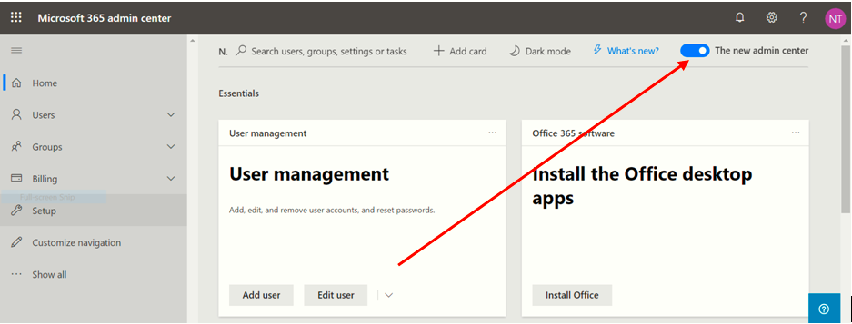

This is the modern page to change this modern page to classic make off the top **The new admin center** button.

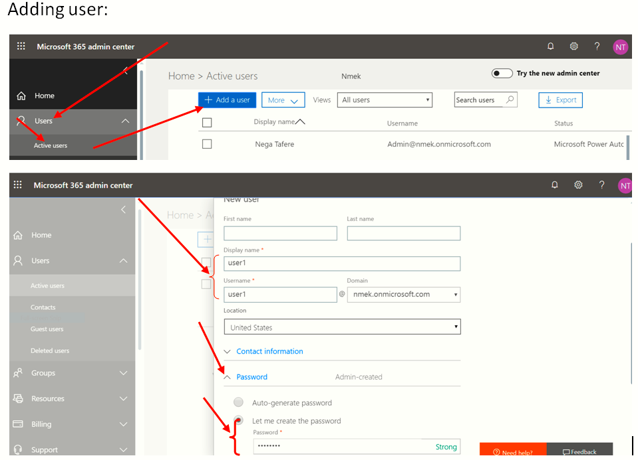

Just fill the required part only. How do you know the required part? By looking asterisks(*).

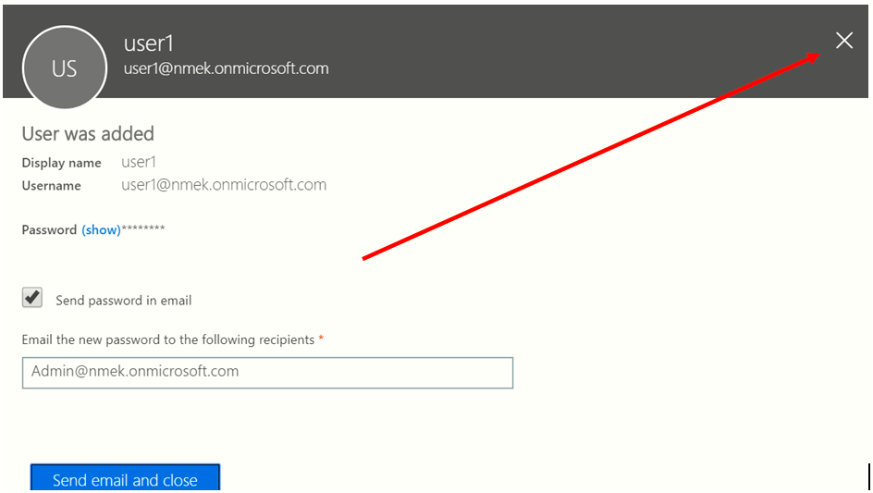

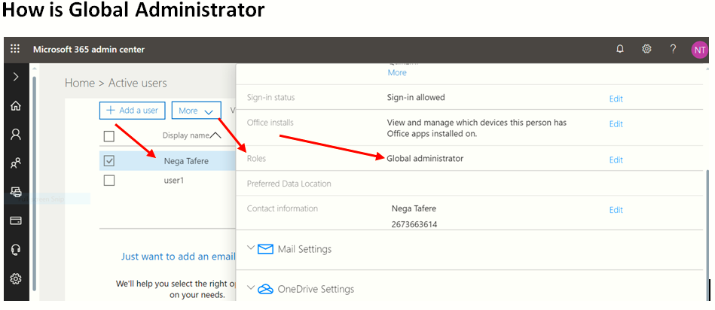

**How to Open SharePoint Admin center:**

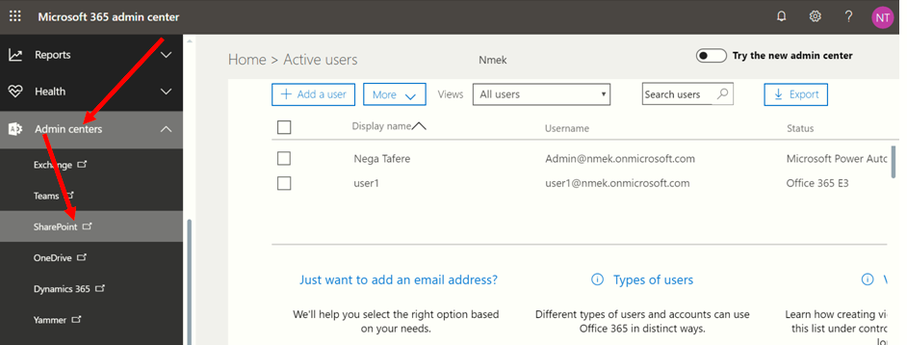

Look at the step at: Pdf file name- 003. SharePointIntroduction

**Office.com**

TesGari:Site collection URL: <https://www.youtube.com/playlist?list=PLTnyE_-cZNW1o-ZbFohq-D7K8ddNOS0tu>

My Site collection: URL: <https://eyos2011.sharepoint.com/sites/Demo/SitePages/Home.aspx>

**To do this**

**Office.com=>Admin=>SharePoint=>**

<https://eyos2011-admin.sharepoint.com/_layouts/15/online/SiteCollections.aspx>=>Private site collection->Put title/Fill everything/->ok->referesh

**Note1:**

* Office.com/
* Admin

If we want to change the screen to the old one make off on “The **New Admin center**” button

* 1. Definition for User**:???**
* **Active Users** -> to see how many users we have
* **Add Users**-> to add users but we put **display name** and **user name** and then the pw only active “**Let me create …”** and use the same user to the last our users until he/she use her own users/new one.
* Add by using next next
* **Then close the page**-> then the new user added but he/she is **not Global admin**. The Global Admin is only the first one.
* If the user quit that job the campany doesn’t delet his list they do **deactivate**. Which will the licence off. Why?

# 2. SharePoint Admin center

* **Show all Expand->Admin Expand**
  1. Site collection: is kind of container. It has a number of sites. Each site collection has its own unique URL. So any one can use our online document by using that link.
* Click URL->Click URL

Mostly Our Common SharePoint Page is Classic but if you want to change the page

Use: **Classic feactures->More Feactures->then select your favorite page style either classic or others.**

* 1. Creating New site collection**:**
* site collection->New->Private site collection->Put title

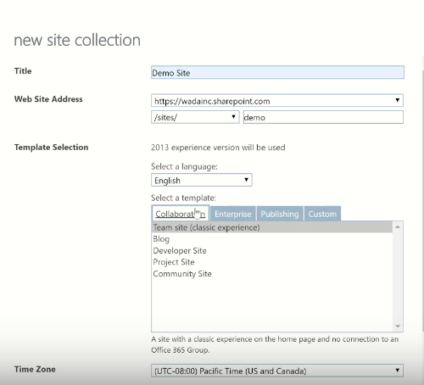

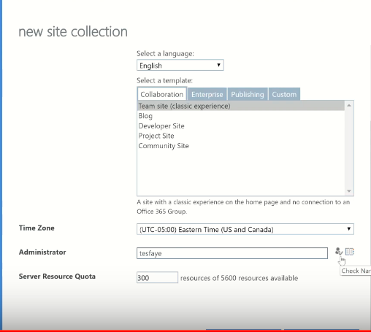

Put the required:

* Title
* URL
* Template
* Ok->Refresh
* Click on New URL-> URL then **SharePoint Page is opened**. and then keep my site collection URL: <https://eyos2011.sharepoint.com/sites/Demo/SitePages/Home.aspx>
* Then we have our own work space and we have full control on it.
  1. Adding Users**:**

Waffle menu =>Admin =>User =>Active user => Add user

Web = subsite

/////////////////////////////////////////////////////////////

Sharepoint highly started after 2007

Platform: SharePoint created for everybody but by using necessary apps they use fot their company.

**Hippo**: personal information

1.**What is SharePoint?**

* a platform to support collaboration and content management system
* a central web-based portal
* collaboration platform to communicate each other
* content management system to develop software costy
* web-based portal-No need download access Using URL only

**software:**

* **online:** controlled by office 365: uses the recent one
* **on-premise:** controlled by SharePoint – that is our server uses the **as we want**(Sharepoint 2010, Sharepoint 2013, Sharepoint 2016, Sharepoint 2019)

2. **What is the purpose of SharePoint?**

**It enables to manage our:**

* colleague’s and your own documents,
* social activities,
* data, and
* information 
*  It allows groups to set up a centralized, password-protected space for document sharing.
* Documents can be stored, downloaded and edited, then uploaded for continued sharing.
* SharePoint offers such a wide array of features that it is very challenging for any one person to be an expert across all the workloads.

**3. How many separated Area it has?**

* **Collaboration**
* **Interoperability**
* **Platform**

4. What is **Collaboration?**

It means bringing people together through different types of collaboration, **such as:**

* Enterprise content management,
* Web content management,
* social computing,
* discoverability of people and their skills.

**5.How to manage collaboration?**

* managed through Apps. Developers can extend, customize, or build their own Apps for SharePoint as well manage collaboration on SharePoint.

**6.** What is **Interoperability?**

bringing this collaboration together through interoperability

such as-

* Office and web-based document integration.
* Capability to build and deploy secure and custom solutions that integrate line-of- business data with SharePoint and Office.
* Integrating with wider web technologies, or deploying applications to the cloud.

We can use Microsoft office (word , exel..) without having on our computer.

7. What is **Platform?**

not only interoperability and collaboration but also extensibility, through a rich object model, a solid set of developer tools, and a growing developer community.

* One of the key paradigm shifts is the notion of the cloud in SharePoint.
* The cloud introduces new App models such as-
* New ways of **developing, deploying, and hosting** SharePoint applications.
* New forms of authentication through **OAuth.**
* New ways of data interoperability using **OData and REST.**

**8.How do we install and use SharePoint?**

There are three main ways to install and use SharePoint-

* SharePoint Foundation –free version but the features are not full
* SharePoint Server –down load by purchasing license
* Office 365

The **first two options** are SharePoint **on-premise**, while **Office 365** has emerged as a third, fully cloud-hosted model for SharePoint.